Dear TRAX Installer, ©1996 TRAXsales – Patent Pending

To remove all confusion, please email (sales@traxsales.com) (and your reps email if possible) three panoramic photos of the entryway from inside and back about 30-40 feet is ideal. One pic from the left, one from the right and one straight on so we can see not just the doorway(s) but also the walls and ceiling in that entire area in one pic.
We will then send you back a photo with our suggestions on where best to mount the camera.
Step 1. Before you run the cable in the ceiling please plug the unit into the internet/POE and make sure you can see the light on the camera and the unit is connecting to the configuration web site with all necessary ports being opened before you begin. Please call Trax at 713.466.7177 to verify before you do anything else!

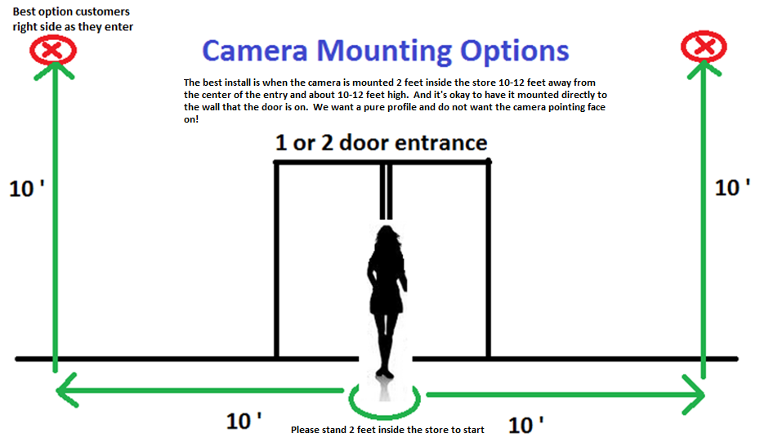
Step 2. Do not install the camera face on. The ideal scenario is a profile picture of the entry, with the actual doorway on the side of the image. In other words, the best place to install the camera is approximately 10 feet high and 10 feet to the left or right of the doorway.

If you have a standard double or single door entryway please stand 2 feet into the store standing on the welcome mat then mark off 10 feet to the left or right and go 10 feet high. Anything within 3 feet of this location is a good install. Just try not to be too close or too far from the doorway and call before you secure the system. Customers typically have a tendency in the USA to turn right so if possible mounting on the right side is best.
Tech Support Hotline – (713) 466-7177

We recommend that you connect to the closest internet connection on your sales floor and do not try to run all the way back to your computer room if possible. If you go over 300 feet the POE might not work. The shorter the wire run, the better!
Facing the camera head on can cause washout from direct sunlight. Please be sure to put the camera up high enough where kids and customers can’t play with it. Also note that if you have very bright sunlight streaming into the store on occasion try and mount the camera on the side of the door that will pick up least sunlight, so the pictures are clean and sharp even during bright afternoons. To be clear mount the camera on the bright side so the background of the photo is not flooded with light.

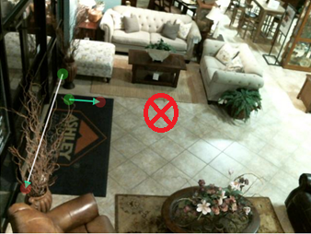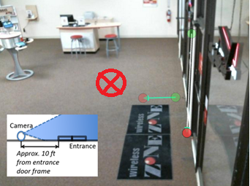
When positioning the camera please make sure that the camera is pointed approximately 6-8 feet into the store so that the photos will show the doorway on the edge of the picture. The red X on the center of the phots above marks the spot.

Visual Proof is a plug and play device however we need ports open within your router for the system to connect to the internet. Ports are listed below:

Outbound Only Ports 80, 123, 443, 22, High order ports ranging from 24550-80 and-25550-80. All these ports are to be opened within the router for Visual Proof’s MAC address located on the side of the Visual Proof control box. See Diagram below for set up instructions: To verify that all ports are open the Controller has self diagnostics that tell you if a port is closed. If the system has a light consistently flashing you have a closed port.
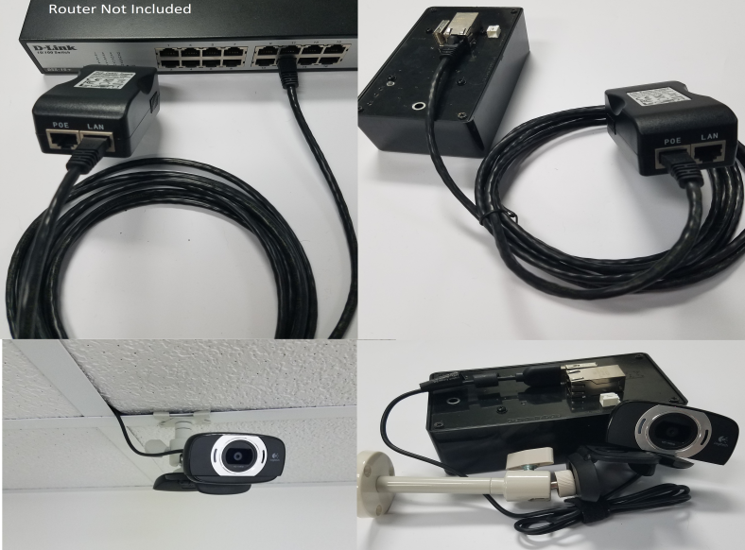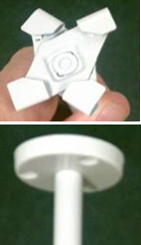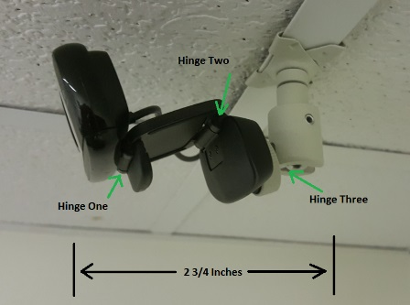
If you are having difficulty please send photos from your cell phone from back about 50 feet so we can see the top half of the entryway and most importantly the walls and ceiling from 20 feet on either side of the entry in the same photo. We will reply with a photo showing where x marks the spot. Please send this email to support@traxsales.com then call 713.466.7177. We are there to assist 9-5:30 M-F. If you call on the weekend someone will typically be on call to assist you.
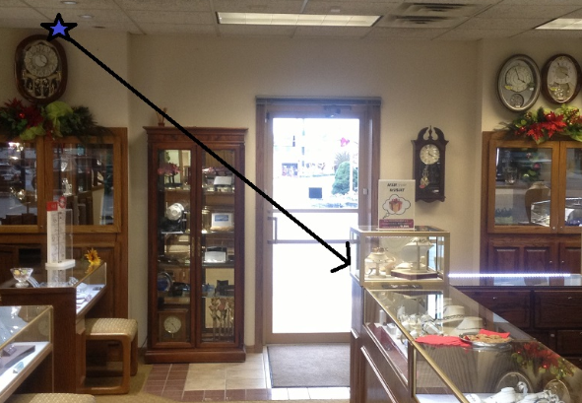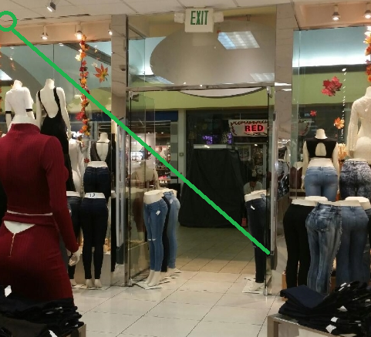
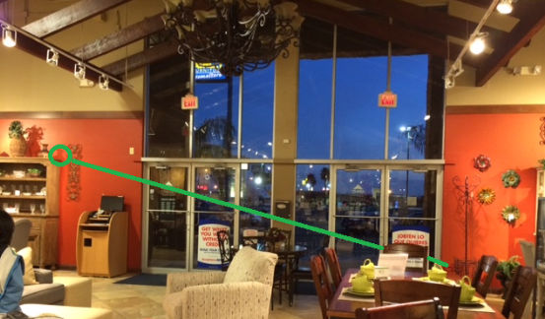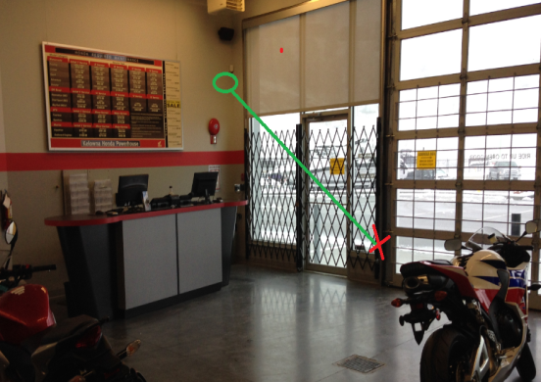

There are two Ethernet Cables included. One short one (5 feet) that is attached from the router or hub to the POE injector/Power Supply and the long cable that is attached to the Trax Controller at the front of the store. The short Ethernet Cable connects from the Router or Hub to the POE Injector (black power supply) and connects to “Data In” then the long cable that is connected to the Visual Proof Controller in the ceiling is connected to the Power Supple connection marked "Data and Power Out”

Trax provides pre-terminated CAT6 cable but if you are using your own cable please use a straight through termination.
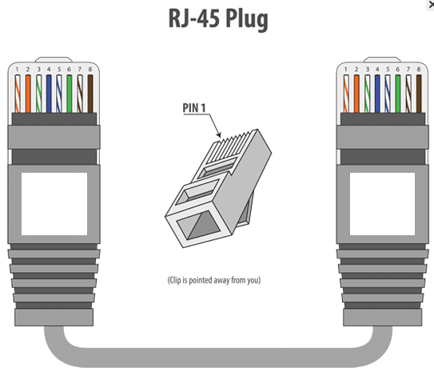
Cat6 (RJ-45) Standard pair order - Orange/White, Orange, Green/White, Blue, Blue/White, Green, Brown/White, Brown
Other helpful hints when installing the Visual Proof Trax Unit
- Always make sure that the camera is pointed where the writing on the front is right side up.
- The camera rests on a double hinge mounting bracket with a wide field of view. DO NOT over tighten bracket
- For a drop ceiling use the scissor clamps to mount the camera on the ceiling grid, or you can use the screw mount for a wall installation.
- We also have included a small clear plastic bag containing a short 1’ Ethernet test cable and 2 extra CAT6 RJ-45 Terminators please keep these if there are any problems in the future with your long cable and for testing.

The Visual Proof 2 TRAX Patent Pending Technology is unique in that we draw a profile line to determine how the customers are counted as they enter. This line can be placed anywhere that will appropriately catch all activity through the front door. We do not count when people are leaving, we can count a family of 5 as one count and non customer counts such as the UPS driver or employees can be easily removed for nearly 100% accuracy.

We need the camera to be installed so that we see a profile image and not a face on view of each person. The goal is to not display anything outside the store in the picture, and to show the doorway on the edge of the picture if possible. Many stores have massive sunlight, and we do not want to display white hot sidewalks because the pictures will then be very dark. We have learned that every install is different and if we work together, the typical install is fairly straight forward once you understand the intent of the system.

Once cabling is complete a tie-wrap should be inserted through the strain relief mounting and all cables secured by this tie-wrap to avoid any damage to the Visual Proof controller unit if any cable is pulled with excessive force.

OPERATION

There are considerable diagnostics abilities programmed within the Visual Proof module and to understand the capabilities it is useful to review the features described in the image below.

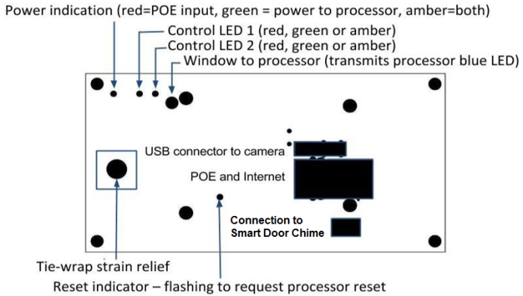
The following is the sequence of operation explaining better the operational features:
- When power is first applied the power indicator turns red, then amber, red indicating that power is being received by the unit and red plus green (viewed as amber) indicating this power is also being applied to the processor.
- Control LED 2 starts pulsing amber after a few seconds and continues pulsing at one second intervals for about a half minute while system is setting up. The camera light will come on after the first few pulses.
- Control LED 2 will stay on for a few seconds
- Control LED 2 will turn green if a valid connection is made.
- If an error was encountered Control LED 2 will flash red sequentially indicating the error condition or conditions. One flash indicates no Port 80 connection, two flashes indicates no Port 443 connection, three flashes indicates no Port 123 connection, four flashes indicates no DNS and five flashes indicates no reverse connection (probably high order ports blocked in at least one direction).
- On the removal of power the power indicator should go solid green indicating battery power to the processor during shutdown. Control LED 2 will briefly flash to indicate a request for the processor shutdown.

Visual Proof is a plug and play device however we need ports open within your router for the system to connect to the internet. Ports are listed below:
Ping (ICMP) to argus.lambsys.com
Port 443 outbound to diagnostics.lambsys.com - for check-in
Port 80 outbound to diagnostics.lambsys.com - for check-in
Port 123 outbound to pool.ntp.org and/or diagnostics.lambsys.com - network time protocol
Port 22 outbound to argus.lambsys.com
Also the range of unprivileged ports from 24000 to 26000

All these ports are to be opened within the router for Visual Proof MAC address located on the side of the control box. To verify that all ports are open the Controller has self-diagnostics that tell you if a port is closed. See Operation item 5 for an explanation of this diagnostic.

Our goal is to be able to set up the line configuration so that we do not pick up any activity inside the showroom or outside of the entryway.
After your system has been installed, we will schedule a training session with you on how to maximize the use of your eTRAXsales.com website we have set up for you. We have four levels of security so a store manager can see his or her store information only. We also have administrative and non administrative password settings so you can allow access to the data and still maintain security.

You have two options regarding accuracy of your traffic counts. We do not count as people leave, but you still need to factor in non-customer activity. You can remove the excess counts manually each day to gain nearly 100% accuracy. It takes about 1 minute to go through 100 photos. If you do not want to manually remove pictures, you can have a percentage of non customer counts automatically removed each hour so that the reports are delivered automatically with no human intervention. The typical mail man factor is 19%, but every company is different, so we suggest that after a week or so, you count your non-customer traffic and make this determination for yourself.

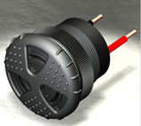
If you purchased the Smart door chime please connect to the top of the Visual Proof Controller and we have provided 100 feet of speaker wire so you can install the actual speaker back towards the salesperson area. The desire here is to not have customers hear this when they walk in. This chime only goes off when people enter, not when they leave and the volume can be adjusted by twisting the audible volume cover to the desired level. If you have multiple entrances the “Smart Door Chime” can also be programmed so that it makes a different sound for different entrances.

If you ever have any questions please do not hesitate to call 713-466-7177 and thank you very much for your business.

Warmest regards,

Technical Support - (713) 466-7177 Support@traxsales.com
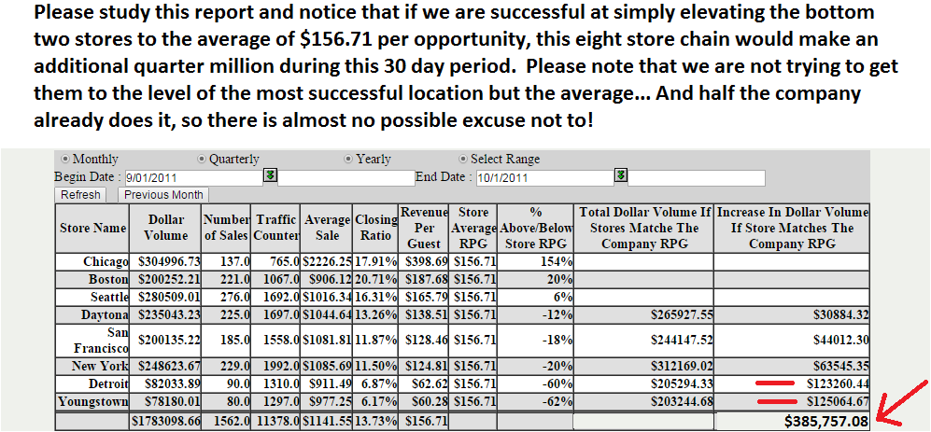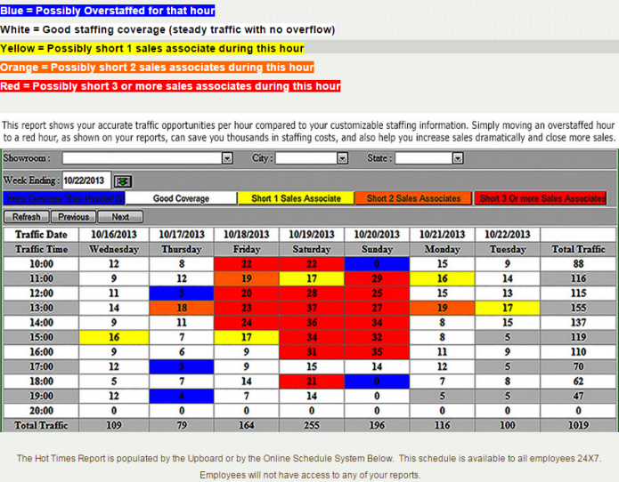
• BABTA Average Sale by Salesperson….. identifies any salesperson with an average profit that is below the company average and also identifies how much more they would earn for the company if they simply hit the average.
• BABTA Average Sales By Store…. Same as previous but totaled for each store and especially powerful when dealing with larger companies and also the corporate overview.
• BABTA Average Closing Ratio by Store….
• BABTA Average RPG by Store…. One of the most powerful reports we provide. RPG “Revenue Per Guest” is the value on every opportunity that comes into the company if they purchase or not and is the truest measure of a company’s potential. This is the report if used properly with multiple store chains where we guarantee a dramatic improvement in sales performance if used properly.
• Revenue Per Guest is a detailed analysis and comparison of Closing Ratio compared to Average Sale and also allows a dealer to create “what if” type scenarios of potential increased closing ratios or Average Sales in different markets.
• Visual Proof is where each dealer or individual showroom manager can go in a view or remove pictures of employees or for example the mail man and for the first time in retail history have an easy to monitor nearly 100% accurate customer traffic count.
• Traffic Analysis is an analysis of daily weekly, monthly, quarterly or yearly on one easy to read screen also displaying percentages of differences for each period so you can easily see immediately if as a dealer you are getting better or getting worse! This report also may be viewed by Showroom, City, State or Profit Center.
• Hourly Traffic is a weekly analysis of hourly activity with totals for each day and totals for each hour of the week.
• History Reports 4 reports that track long term history analysis of RPG, Average Profit by store, Sales Volume compared to traffic and Closing Ratio History.
• Staffing Analysis details the comparison each hour of sales coverage compared to true customer traffic patterns.
• Hot Zone Report is the comparison of employee coverage per hour to actual customer traffic on a color coded weekly report that immediately tells a dealer if they are overstaffed or understaffed at any time during the week.
• Company Sales Goals 4 reports that comprise a proprietary sales goals program that breaks down the weekly profit goals for each salesperson and insures that they are aware of their position compared to the rest of the company.

