What we need to get your Visual Proof System Set up Properly.
Please email this back to sales@traxsales.com and we will set this up for you then we need 30 minutes for our basic training boot camp.
- Each Showrooms Name, Address, Phone Number, Managers Name, Managers Email
- All Salespeople’s Names, and POS ID
- Annual Sales Goals for each store
- A sample of each stores schedule for 1 week
- A report from your POS in Excel which has your daily sales by salesperson and number of transactions so we can show you how to set up this automatic reporting service.

Setting up your New Visual Proof Opportunity Tracking System
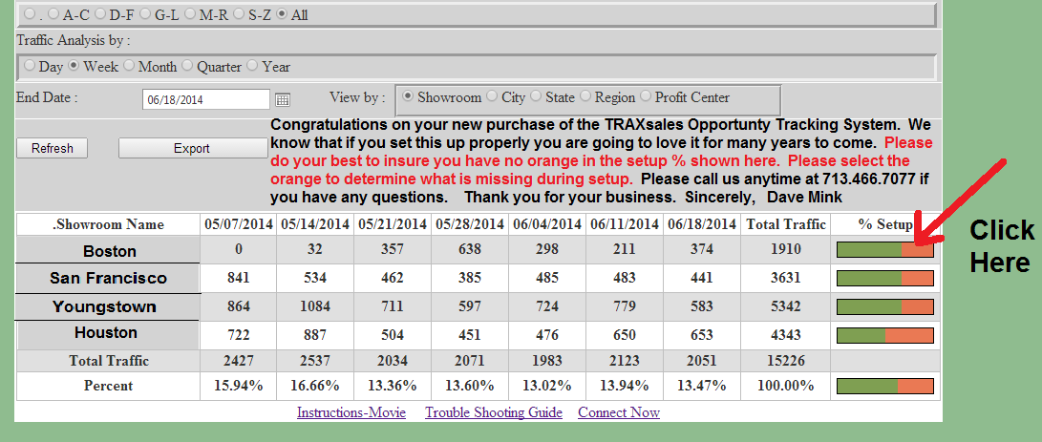
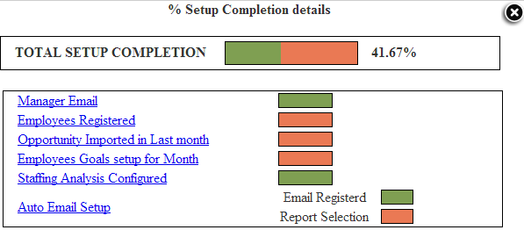
Our goal is to get Argus Completely set up properly so that you can fully enjoy the system and see how this new knowledge will help you grow sales with the same number of opportunities.
How To Set Up The Argus System.
#1. Please go to the Showroom Page under <Administration>
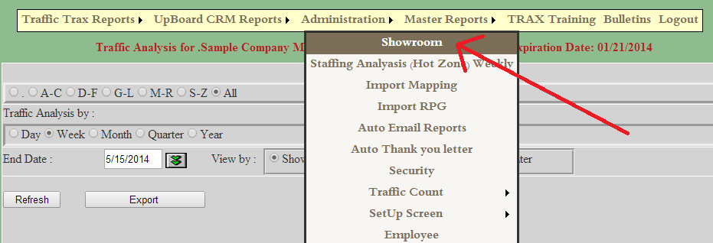
Please fill in every field that is applicable. Make sure you include separate showroom phone numbers and most importantly the managers name and email address .
#2. Set Up Employee’s. (Halfway down Administration) If you keep track of individual employee sales you should absolutely set this part of the program up. This will populate the finest sales goals program in Retail and also provide the BABTA Analysis regarding Average Sale. Make sure you include email addresses if you use the UpBoard. If you don’t track individual sales make sure you set up one heading for each store with the correct store ID number and goals will work for your entire company in the same way.
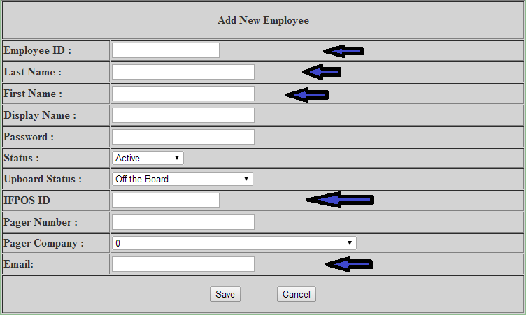

#3. Most importantly set up import of sales data. First find the report in your POS that gives you these five things Showroom ID, Salesperson ID, Date (by day), Sales Amount, # Transactions and save this in a CSV or Excel file on your desktop.

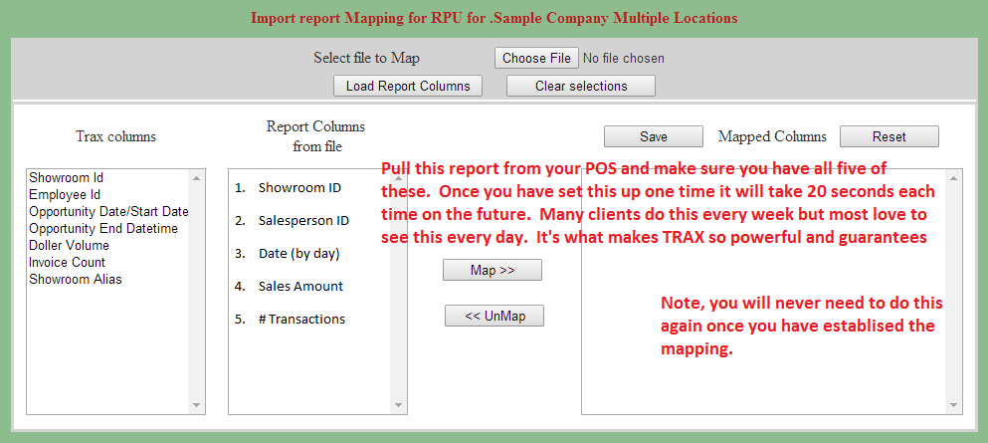
Example of an actual Excel file ready to import.
Then please select Import RPG. Once set up this should take no more than 20 seconds.

If you have any questions or problems with this please do not hesitate to call us immediately. 713.466.7177 or if after hours please call 713.854.7706.
Our email is support@traxsales.com and we look forward to your feedback.
This is the most important part of the program and will insure that you will be delighted with this system for many wonderful years to come.

#4. Goal Setup.
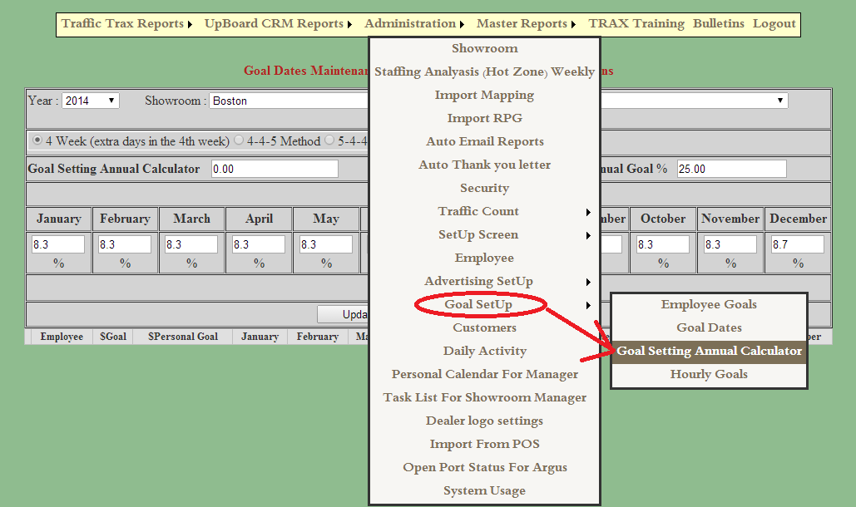
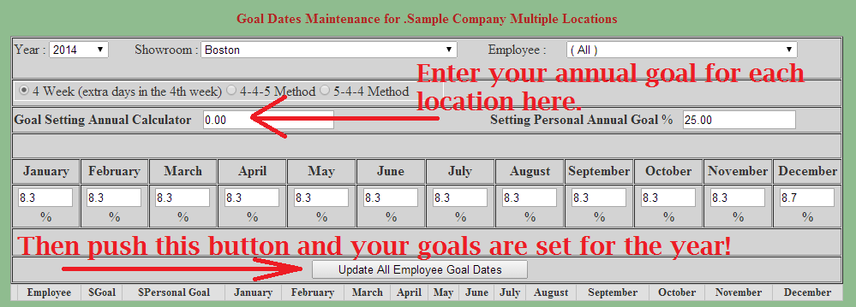
It is also very helpful and more accurate for you if you can take your percentage of business per month and set up your goals accordingly. For example most companies have a different percentage of business done for February or June or November. What were your exact percentages last year? Please put them into the Goal Setup page <Goal Setting Annual Calculator> for each month and our system will automatically calculate this for the entire year for each sales associate. Please make sure your total percentage for each month adds up to exactly 100%. You may also go out to several decimal places if desired.
#5. Set Up Staffing Analysis (Hot Zone) Weekly
This is the second item located under <Administration> and change the # of employees working each hour to match your typical schedule. If you have multiple locations that have similar coverage you may also select <Update All> then go back and adjust those showrooms with more or less sales coverage.

#6. Set Up Automatic Reports
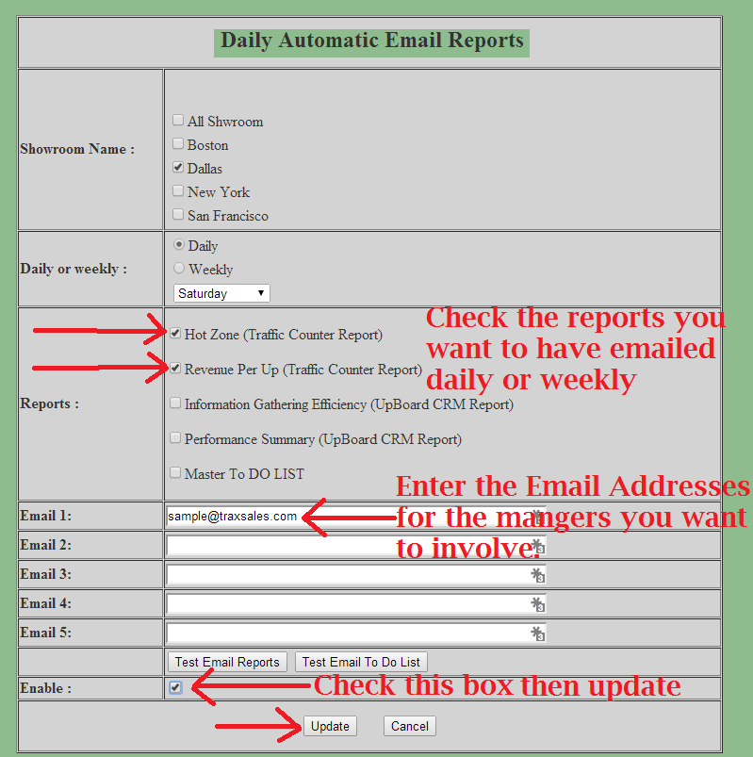

Thank you again for your purchase and congratulations. Our goal is to absolutely help you increase sales and grow your company. I know this sounds like a tall order but I know we can do great things together if the system is set up properly and is automatically providing you the information you need to make better educated decisions regarding staffing and most importantly how to increase sales activity and grow your business.
Please do not hesitate to call if you have any questions or comments about anything dealing with the system.
TRAXsales Tech Support
713.466.7177

