How to use the Import RPG page to import your sales.
To get to this page you will go to the Administration Tab then select Import RPG from the Dropdown as shown below:
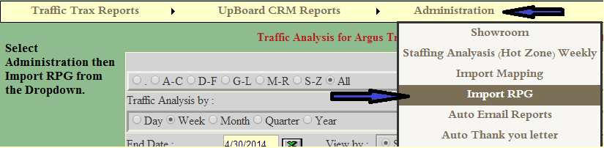

Once done that will look like the following:
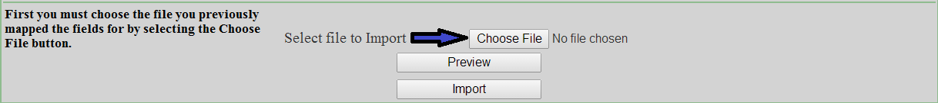

Once done that will look like the following:
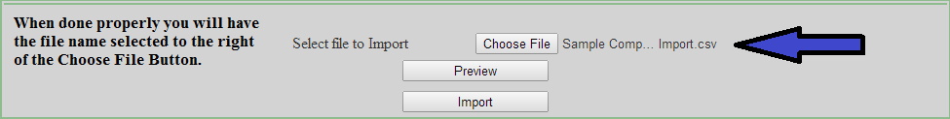

When you have gotten to this point you will left click the Preview Button:
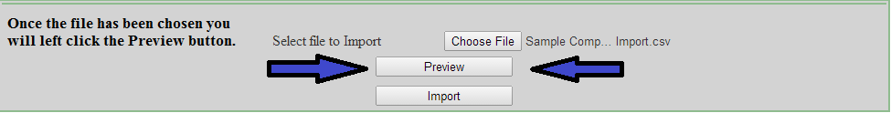

Once this has been done it will look like the following picture:
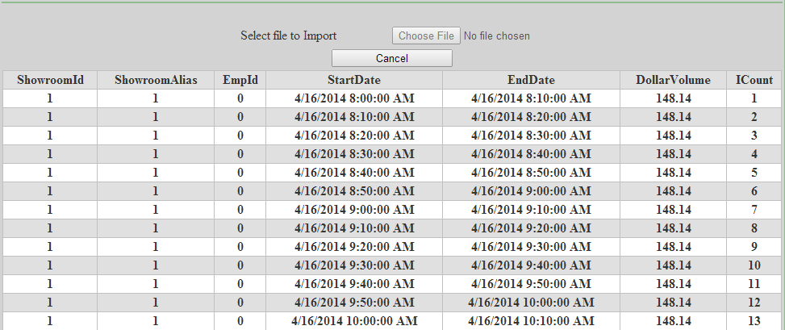
Now all you have to do is left click the Import button on the bottom of the page to load all of your sales into your www.etraxsales.com site. Example below:
